**KNITTING EXAMPLE**

1. **Open RStudio**

1. **Save the File – File > Save/Save As**

1. **Remember the location/Give a proper destination.**

1. **Rename the File – Right-click on the file name on top left**

1. **Change name to Rmd – Add “md” at the end of the file name**

1. **You can now see that the file name on top left changed to a red circle with Rmd instead of a blue circle**

1. **Adding a title and output file type – We can check this output at the end**

1. **Adding a new code line – Click on the option highlighted**

1. **Adding headings and bold text – the number of hashes defines it – You can check this in the final output**

**10. Adding hash inside R code and adding bullets**

**11. Run within the console gives you can option to check the individual chunk output before knitting the complete file**

**12. Sample output within console**

**13. Adding a heading to the plot – Include “main” inside the plot command**

**14. “?<function>” – Gives you details about the function**

**15. Multiple options for the plot – In our case, we choose a Generic plot – This gives a detailed explanation of the function**

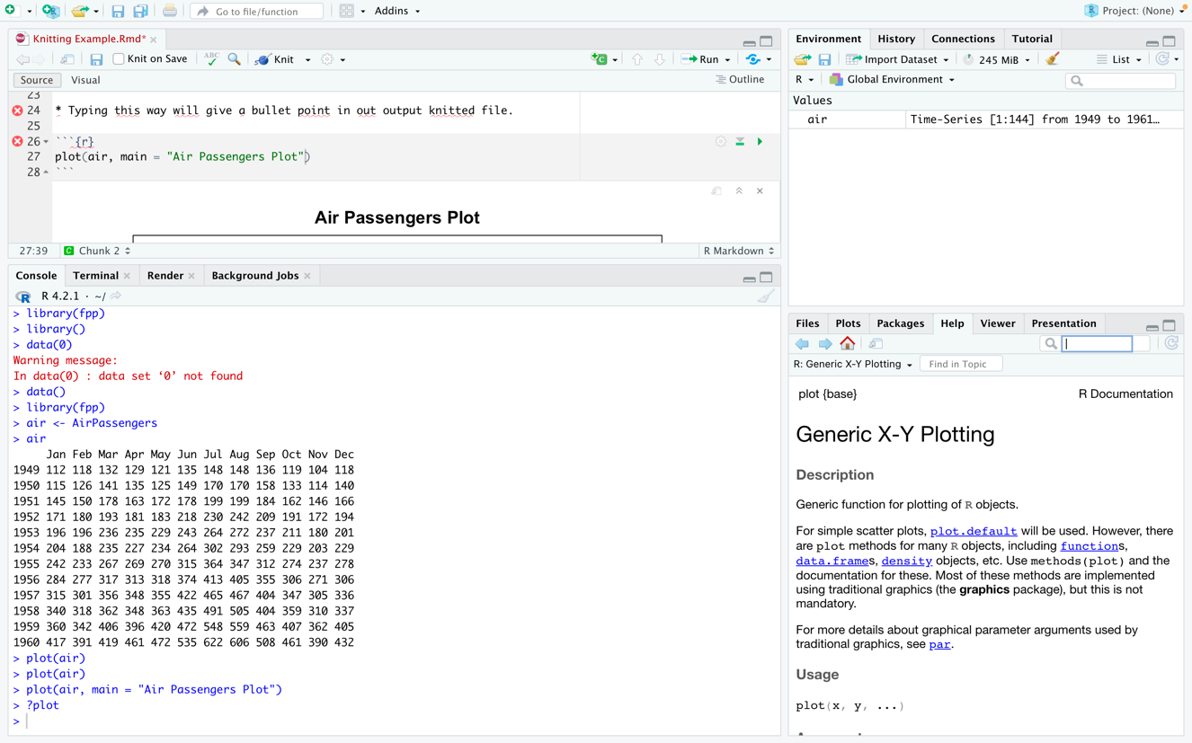

**16. Scroll down to see what all you can use within the function and what each of them can do**

**17. Knitting the file – Click on knit on the top**

**18. Output Html – Check the sizes of each heading – Proportional to the number of hashes we used earlier**

**19. Check the output HTML – How the hashes inside the R code are visible and how the bullets are visible**

**20. The HTML file will be saved in the same location that you saved your Rmd File**

